The Biodiversity Finance Initiative (BIOFIN):

The Biodiversity Financial Needs Assessment in Sri Lanka

Contents
Contents i
List of Abbreviations iii
List of Tables iv
List of Figures v
Executive Summary vi
Acknowledgements viii
1. Introduction 1
2. Methodology 3
3. Results 9
4. Conclusions and Recommendations 25
References 27
Annexes 28
Annex 1: Structure of the IUCN Team 28
Annex 2: List of Stakeholders Consulted 29
Annex 3: Expenditure Classification by Department of National Budget 34
Annex 4: List of NBSAP Actions 38
Annex 5: Detailed Costing Tables 43

List of Abbreviations

BCAP Biodiversity Conservation in Sri Lanka: A framework for action
BDS Biodiversity Secretariat
BER Biodiversity Expenditure Review
BIOFIN Biodiversity Finance Initiative
CBD Convention on Biological Diversity
DWC Department of Wildlife Conservation
EEVR Environmental Economic Valuation Review
FD Forest Department
FNA Biodiversity Financial Needs Assessment
IUCN International Union for Conservation of Nature
LKR Sri Lankan Rupees
MMDE Ministry of Mahaweli Development and Environment
NAP-CC National Adaptation Plan for Climate Change Impact in Sri Lanka 2016-2025
NAP-CLD National Action Programme for Combatting Land Degradation in Sri Lanka 2015-2024
NBSAP National Biodiversity Strategic Action Plan 2016-2022
NRIFAP National REDD+ Investment Framework and Action Plan
PIR Biodiversity Finance Policy and Institutional Review
REDD Reducing Emissions from Deforestation and Forest Degradation
UNDP United Nations Development Programme

List of Tables
Table 2.1: Summary of NBSAP 2016-2022 5
Table 2.2: BIOFIN Categories 7
Table 3.1: Financial Needs for Delivering National Biodiversity Targets 9
Table 3.2: Finance Needs According to the Prioritisation of NBSAP Actions 11
Table 3.3: Financial Needs for Biodiversity Conservation According to BIOFIN Categories 15
Table 3.4: Finance Needs According to Aichi Targets 16
Table 3.5: Financial Needs According to Key Agencies 18
Table 3.6: National REDD+ Investment Framework and Action Plan 20
Table 3.7: National Adaptation Plan for Climate Change - Ecosystems and Biodiversity Budget 20
Table 3.8: Biodiversity Related Cost Estimate of the National Action Plan to Combat Land Degradation 21
Table 3.9: Financial Needs for Biodiversity Conservation According to All Strategies 22
Table 3.10: Financial Needs According to Cost Category and Timing 23
Table 3.11: Financing Gap 24

List of Figures
Figure 2.1: Financial Needs Assessment Process 3
Figure 3.1: Comparison of Financial Needs of the 12 NBSAP Targets 11
Figure 3.2: Percentage of the Cost of NBSAP Actions According to Prioritization 12
Figure 3.3: Biodiversity Priority and Cost -Comparison Matrix – Low Costs 13
Figure 3.4: Biodiversity Priority and Cost -Comparison Matrix – Medium Costs 14
Figure 3.5: Biodiversity Priority and Cost -Comparison Matrix – High Costs 14
Figure 3.6: Distribution of Financial Needs According to Aichi Targets 18
Figure 3.7: Relative Costs of Biodiversity Strategies 23

Executive Summary
The Biodiversity Finance Initiative, or BIOFIN, is a UNDP-managed global collaborative partnership to develop and implement an evidence-based methodology that improves biodiversity outcomes using finance and economics (UNDP, 2016). The Biodiversity Financial Needs Assessment (FNA) is one of the components in BIOFIN which aims to make a comprehensive estimate of the financial resources required to achieve national and sub-national biodiversity targets. It compares these financial needs with projected biodiversity expenditures over a medium to long-term planning horizon in order to estimate the finance gap for biodiversity conservation in the country.
The specific objectives of the FNA are as follows:
- To clarify the strategies and actions in the national biodiversity plans in order to describe “costable actions” and provide a logical framework for positive outputs in biodiversity conservation.
- Produce a detailed budget for each costable action by defining unit costs and quantities over the target time frame.
- Use the detailed budgets to make a strong case for biodiversity finance, by incorporating the costs of achieving specific results to the national budget processes.
- Prioritise biodiversity strategies and actions based on specific biodiversity and cost criteria.
- Connect the FNA to the Biodiversity Expenditure Review (BER) through a tagging system that associates financing needs with expenditure categories, sectors, and organizations.
The FNA follows on from the Biodiversity Policy and Institutional Review (PIR) component of BIOFIN, as it considers the key national strategies in the PIR for costing in the FNA. In this regard, the National Biodiversity Strategic Action Plan 2016-2022 (NBSAP), National REDD+ Investment Framework and Action Plan (NRIFAP), the National Action Programme for Combatting Land Degradation in Sri Lanka (NAP-CLD) and the National Adaptation Plan for Climate Change Impacts in Sri Lanka (NAP-CC), were selected as the relevant plans and programmes for conserving biodiversity in Sri Lanka for the FNA. The NBSAP was considered in its entirety for the costing of actions, while actions relating to biodiversity conservation were selected from the other three plans and programmes. The costed actions were then analysed to estimate the financial needs for biodiversity conservation in Sri Lanka. This entire process was guided by the BIOFIN workbook (UNDP, 2016) and in close engagement with key stakeholders through consultative and participatory workshops, meetings, team discussions and expert inputs.
The NBSAP actions were further ‘unbundled’ or subdivided in to costable activities to facilitate costing. The other three plans and programmes (NRIFAP, NAP-CLD, NAP-CC) used for FNA were available with the cost estimates, hence those costs were used directly in FNA. The results of the FNA demonstrate that a total of LKR 30.71 billion is required for the achievement of the biodiversity conservation goals of the NBSAP, NRIFAP, NAP-CC and NAP-CLD. The financial needs of biodiversity goals of the NBSAP is LKR 13.44 billion, the NRIFAP is LKR 14.88 billion, the NAP-CLD is LKR 1.89 billion and the NAP-CC is LKR 501 million. In addition, by comparing the BER, or the current expenditure towards biodiversity in Sri Lanka with the FNA results, it was possible to estimate the finance gap for biodiversity conservation in Sri Lanka. However, the FNA process for Sri Lanka differed slightly from the process outlined in the BIOFIN workbook. In FNA calculations, the actions identified in the four plans and programmes (NBSAP, NRIFAP, NAP-CLD and NAP-CC) were considered as incremental costs to the baseline expenditure on biodiversity conservation. Therefore, for BIOFIN Sri Lanka, the financing gap for biodiversity conservation is the estimated FNA in this study. This also requires a change in how the total FNA is obtained, and it has therefore been proposed that the finalised BER will be added to the current FNA estimate (LKR 30.71 Billion) in order to reach the comprehensive FNA for Sri Lanka. In addition to this change in the process, there were some challenges concerning limited detail related to the costing of NRIFAP, NAP-CC and NAP-CLD; lack of sub-national biodiversity conservation plans/programmes; and a tendency to use low cost estimates for government organised activities. This may have led to an underestimate of the FNA for biodiversity conservation in Sri Lanka. Nevertheless, the results of this report is vital for the next steps of BIOFIN, in informing the biodiversity finance plan for the country and in mobilising financial resources for biodiversity conservation and the sustainable development of Sri Lanka.

Acknowledgements
Participated agency representatives, group leaders, rapporteurs and facilitators of the FNA workshops, Mrs. Pathma Abeykoon, Director Biodiversity Secretariat (BDS) and Mrs. Hemamali Herath of the BDS for coordinating communications through the Ministry of Mahaweli Development and Environment and the other staff of the BDS for their participation in FNA. Mr. Ramitha Wijethunga, Coordinator BIOFIN and Mrs. Sashika Selavaratnam of UNDP for funding and coordination support provided throughout project duration are gratefully acknowledged. Professor Sirimal Abeyratne for reviewing and guidance on FNA as the Lead Consultant in UNDP BIOFIN in Sri Lanka. The team of consultants, Mr. Sampath Bandara, Ms. Radheeka Jirasinha, Mr. Sampath Goonatilake, Professor. Devaka Weerakoon and Mr. Naalin Perera of IUCN for their contributions to FNA report and to FNA process are also gratefully acknowledged.

Introduction
The Biodiversity Finance Initiative (BIOFIN) is a UNDP managed global collaborative partnership to develop and implement an evidence-based methodology that improves biodiversity outcomes using finance and economics (UNDP, 2016). The Biodiversity Financial Needs Assessment (FNA) is one of the components in BIOFIN and) is an attempt to estimate the financial resources required to achieve biodiversity targets set by a particular country in a methodical and comprehensive manner. The BIOFIN Workbook (UNDP, 2016) provides a descriptive guide into assessing the financial needs of a country and recommends that the analysis should cover both national and subnational biodiversity targets. By estimating the biodiversity conservation finance needs of a country, the process not only assists in the development of a finance plan to generate new resources and/or improve the allocation of existing resources, but also provides prominence to the issues surrounding biodiversity conservation and the importance of investing in biodiversity. The investment in biodiversity and ecosystem conservation is recognised as an investment into sustainable development due to the economic returns generated from healthy ecosystems and ecosystem services. Therefore, the investment towards achieving national biodiversity targets in a timely manner is essential for sustainable development in Sri Lanka. The FNA component of BIOFIN enables the mechanism for financing the national biodiversity targets through a coordinated and effective manner (MMDE, 2016).
Therefore, the overall aim of the FNA component of BIOFIN is to cost the national biodiversity strategies over medium to long term planning period, and to compare the finance needs with business as usual biodiversity expenditure in order to estimate the finance gap for achieving biodiversity conservation goals in Sri Lanka.
The specific objectives of the FNA include:
- Clarifying strategies and actions in national biodiversity plans/programmes in order to describe “costable actions” and provide a logical framework for positive outputs in biodiversity conservation.
- Producing a detailed budget for each costable action by defining unit costs and quantities over the target time frame.
- Utilising the detailed budgets to make a strong case for biodiversity finance by linking the costs of achieving specific results to the national budget processes.
- Prioritising biodiversity strategies and actions based on specific biodiversity and cost criteria.
- Connecting the FNA to the Biodiversity Expenditure Review (BER) through a tagging system that associates financing needs with expenditure categories, sectors, and organizations.
As advised in the Workbook, the FNA process was done in close consultation with the Biodiversity Finance Policy and Institutional Review (PIR) and the Biodiversity Expenditure Review (BER) processes. Since both of these components commenced prior to the FNA, the FNA process was able to benefit from the work done in PIR and BER. For instance, identification of key biodiversity related strategies in the PIR was useful for the FNA, while the key institutions selected for BER were used in FNA and the same representatives participated in both BER and FNA working groups. The experts leading the PIR, BER and FNA components of BIOFIN worked closely together in producing the reports for each component as these are interconnected through the terminology, stakeholders consulted, the analysis, and other factors.
The FNA for Sri Lanka closely followed the guidance provided by the BOFIN Workbook (UNDP 2016), however the main document considered was the National Biodiversity Strategic Action Plan 2016-2022 (NBSAP) (MMDE 2016) as it is the most current and comprehensive strategy for biodiversity conservation in Sri Lanka. Sri Lanka developed the NBSAP in line with article six of the Convention on Biological Diversity (CBD), in order to integrate conservation and sustainable use of biodiversity into sectoral and cross-sectoral activities. The NBSAP is the principal instrument for the implementation of the Convention at the national level. Sri Lanka prepared its first NBSAP equivalent strategy in 1998 with approval from Cabinet of Ministers and it was called ‘Biodiversity Conservation in Sri Lanka: A framework for action’ (also known as Biodiversity Conservation Action Plan or BCAP). The addendum to the BCAP followed in 2007, and therefore the current NBSAP is the third revision of a national biodiversity strategy for Sri Lanka which was prepared in a highly consultative manner and subsequently approved by the Cabinet of Ministers of the Government of Sri Lanka. Despite the NBSAP identifying particular targets for the period 2016 – 2022, there have been a few challenges in the implementation of actions. One such challenge is the absence of detailed costing of actions and a resource mobilisation plan. However, as the BIOFIN project was in the pipeline during the preparation of the NBSAP, it was expected that a detailed resource mobilisation plan will be prepared on completion of the NBSAP through the BIOFIN initiative. Hence, the Financial Needs Assessment (FNA) component of BIOFIN suitably continues on from the NBSAP 2016 - 2022.
Other relevant national strategies finalised around the same time of the completion of the NBSAP or immediately after the NBSAP, were also considered in the FNA process. These documents include the National REDD+ Investment Framework and Action Plan – NRIFAP (MMDE, 2017), the National Action Programme for Combatting Land Degradation in Sri Lanka 2015-2024 – NAP-CLD (MMDE, 2014) and the National Adaptation Plan for Climate Change Impact in Sri Lanka 2016-2025 – NAP-CC (MMDE, 2016). The selected documents for FNA were thorough, comprehensive studies, which capture all aspects of sustainable biodiversity management in Sri Lanka and include all strategies/plans prepared prior to the NBSAP period, thereby foregoing the need to consider previous national documents in the FNA analysis.
The structure of the FNA report for Sri Lanka includes an executive summary providing a concise presentation of the entire process, followed by a general introduction, and the three main sections: the methodology, results, and conclusions and recommendations. The methodology provides detail on the level of engagement of stakeholders, the approaches followed, the main hypothesis used to develop FNA and the sources of data used. The results section is the core of the FNA report, and it provides the findings of the FNA according to the thematic areas, strategic priorities, NBSAP targets, BIOFIN categories and institutions. Thereafter the financial gap is presented based on the difference between the finance needs for biodiversity conservation goals in Sri Lanka and the current expenditure towards biodiversity as identified in the BER component of the project. Finally the conclusion and recommendations section is presented to enable the process of BIOFIN to continue smoothly.

Methodology
In preparing the FNA for Sri Lanka, all actions proposed by the NBSAP 2016 – 2022 and components related to biodiversity conservation from the three other plans and programmes (NRIFAP, NAP-CLD and NAP-CC) were taken into consideration. The following process suggested in the BIOFIN Workbook (Figure 2,1) (UNDP 2016) was adopted in producing a well-documented and argued, prioritised and fully costed budget for achieving Sri Lanka’s biodiversity targets and to materialise the investments in biodiversity.

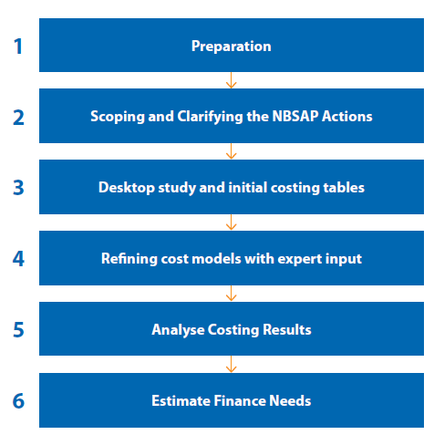

Source: UNDP, 2016

Figure 2.1: Financial Needs Assessment Process

The FNA process began with the endorsement received for the FNA methodology presented at the National Stakeholder Consultation meeting held in September 2017, and thereafter progressed somewhat slowly for the first couple of months, as more attention was paid for the completion of BER (and PIR) components. The IUCN team (Annex 1) reviewed the guidelines set out in the BIOFIN workbook and prepared a plan for the FNA process in Sri Lanka. After several discussions within the BIOFIN team (UNDP and IUCN), including a meeting with the UNDP Senior Technical Advisor for BIOFIN and taking into account the PIR findings thus far, it was decided that the key document under assessment for FNA would be the National Biodiversity Strategy and Action Plan 2016 – 2022 (NBSAP). The 12 National Targets in the NBSAP would be the focus, and in addition other important plans and programmes considered were the NRIFAP, NAP-CLD and the NAP-CC.
The process of assessing the financial needs of Sri Lanka for Biodiversity conservation involved the quantification and costing of these key plans/programmes. This process was carried out at the FNA working group meeting (or workshop), and in preparation for the workshop the IUCN team had the advantage of discussing FNA details with in-house NBSAP contributors (Steps 1 and 2, Figure 2.1). A plan for the two-day workshop was created which involved organising the participants into three groups according to their institution and expertise and dividing the 12 targets among these groups. Group one was allocated NBSAP targets 1 to 3 covering 32 actions while group two were given NBSAP targets 4-7 which included 28 actions and the third group had NBSAP targets 8-12 with 27 actions (Figure 2.2). In addition, a briefing on the activities and expectations of the FNA workshop was given by UNDP and IUCN BIOFIN teams at the end of the BER Working Group meeting (find list of stakeholders consulted in Annex 2).
The FNA workshop was held over two days as a residential event, where 44 participants were present, including representatives from the 16 key public-sector institutions, contributors to NBSAP and national biodiversity experts. The latter assisted in the facilitation of group work and stimulating discussion regarding the NBSAP and current state of biodiversity in Sri Lanka. The workshop proved a successful participatory and informative two day event, with completion of the quantification and costing of the 12 NBSAP targets (Figure 2.2) based on government norms (Steps 3 and 4, Figure 2.1). Relevant sections of the other three plans and programmes identified for BIOFIN were distributed among participants in order to identify the biodiversity related actions/outcomes. It was agreed that the NRIFAP is fully relevant to biodiversity and from the other two plans/programmes certain sections were selected for the analysis.

Table 2.1: Summary of NBSAP 2016-2022
Strategic Objective | Targets by 2022 | Number of Actions
1. Ensure the long-term conservation of biodiversity | - Inventorying species, ecosystems and their values | 9
 | - Habitat loss, degradation and fragmentation reduced | 16
 | - Effectively managed PA network representing all critical ecosystems and species | 7
 | - Loss of species is significantly reduced | 10
2. Promote sustainable use of biological resources | - Valuation of biodiversity is mainstreamed | 7
 | - Mechanisms are established to ensure sustainable use of biodiversity | 5
 | - Traditional sustainable uses of biodiversity are promoted and established | 6
3. Conserve agrobiodiversity | - Sustainable agriculture practices are promoted and established | 6
 | - Genetic diversity of crop wild relatives, cultivated species and livestock is conserved | 5
4. Promote equitable sharing of benefits from biodiversity | - A mechanism for equitable sharing of benefits arising from biodiversity is established and implemented | 5
5. Improve human well-being through the restoration and enhancement of key ecosystems | - The capacity of ecosystems to deliver goods and services and provide protection from hazards is enhanced | 5
 | - Biosafety is assured | 6
Source: based on NBSAP 2016 – 2022

After completion of the workshop, the IUCN team worked towards compilation and organisation of all material. This was then further developed by the team, and with the assistance of NBSAP contributors, a standardisation of costing was carried out based on the national budgeting standards. All collated information was shared with participants who attended the workshop and communication maintained so that the level of engagement and interest persisted. After team discussions and continued work on the NBSAP targets, it was noted that there were a few areas which needed clarifications and further prioritisation of actions and validation exercise was required of the stakeholders. Due to time constraints and the difficulty in organising a workshop at the end of the year, the IUCN team prioritised actions for the 12 targets according to their knowledge and the final worksheet was sent to the relevant stakeholders electronically for validation.
Activities relevant to biodiversity from NRIFAP, NAP-CLD and NAP-CC were extracted by the IUCN team prior to the FNA Workshop so that biodiversity relevant activities to be included into the FNA could be identified by the working group. These materials were also subsequently compiled and shared with participants of the BIOFIN FNA Workshop. The selected activities of these strategies thereby followed the same process as NBSAP activities which included a validation process.
Finally the analysis of financial needs based on the costing of the four plans and programmes were performed (steps 5 and 6 of the Fig.1). The team decided to not use the FNA data tool for analysis and instead to proceed with manual calculations of the finance needs with the extensive use of excel functions. This decision was made around the same time of the decision to not use the BER data tool due to identified constraints. Estimates of biodiversity costs were analysed and sorted according to the Aichi Targets, BIOFIN categories, NBSAP targets (Table 2.1), short term and medium term costs, and costs according to agencies.

Table 2.2: BIOFIN Categories Aligned with Aichi and NBSAP Targets
Aichi Strategic Goals(Targets) | BIOFIN Categories | NBSAP (National Targets)
- Mainstreaming  (Target 1-4) | - Biodiversity awareness and knowledge  - Green economy  - Pollution management | - 5. Biodiversity valuation mainstreamed  - 6. Ensure sustainable use
- Sustainable use  (Target 5-10) | - Sustainable use  - Biosafety | - 2. Reduce degradation and habitat loses  - 8. Promote sustainable agriculture  - 12. Ensure biosafety
- Protection  (Target 11-13) | - Protected areas and other conservation measures | - 3. Effective management of protected areas  - 4. Reduce loss of species  - 9. Conserve genetic diversity
- Restoration  (Target 14 and 15) | - Restoration | - 11. Enhance delivery of ecosystem services
- Access and benefit sharing -ABS (Target 16) | - Access and Benefit Sharing (ABS) | - 10. Equitable sharing of biodiversity
- Enabling  (Target 17-20) | - Biodiversity and development planning | - 7. Promote traditional uses  - 1. Inventorying biodiversity an ecosystem services and values
Source: Adapted from BIOFIN Workbook, 2016
In identifying the timelines for the FNA, the seven-year NBSAP implementation period is taken as 2018 – 2024, which is considered the medium term for FNA of Sri Lanka and the short term is 2018 – 2020. This is because the cabinet approval for NBSAP was received in early 2017 and dedicated funding for NBSAP implementation up to 2018 assumed to be very low other than the baseline budget allocation for biodiversity as captured in BER. Similarly, the five year NRIFAP plan is yet to commence its implementation, however some minor activities towards its initiation may have been implemented. Therefore, the NRIFAP implementation period was taken as 2018-2022. From the other two plans/ programmes, there were relatively smaller contributions to biodiversity conservation outcomes and although the NAP-CLD planned for the period 2014 to 2024 and the NAP-CC planned for the period of 2015 to 2025, biodiversity related activities covering the period 2018 – 2024 from these two strategies were considered for the FNA.
Stakeholder engagement process
Throughout the BER and FNA processes, awareness and engagement of various stakeholders were considered essential for the success of the project. This was achieved in both components of the project where direct and indirect biodiversity related agencies, finance and planning agencies under ministries, departments and statutory bodies, NGOs, private sector and selected individual experts were consulted throughout the process and continue to be engaged in the outcome of the first phase of BIOFIN. There are over 90 representatives from various institutions/organisations that were consulted and made aware of the BIOFIN project in Sri Lanka, and approximately half of these representatives, the selected key stakeholders, were engaged throughout the FNA process (Annex 2). In conducting the FNA, it was ensured that the key stakeholders identified in the PIR, were represented in both BER and FNA proceedings. Therefore the steps taken in the FNA components guaranteed a highly consultative, detailed, interconnected and involved process.
In order to make the FNA compatible with the national planning and budgeting process, the Department of National Budget and Department of External Resources was consulted in the FNA process. This allowed the FNA component to be well aligned with the national budgeting process thereby facilitating effective uptake of FNA results. The National budgeting process is progressively moving from zero balance budgeting towards results-based budgeting, and this is consistent with the NBSAP budgeting process (Annex 3).

Results
The additional financial resources required for the achievement of national targets of biodiversity conservation in Sri Lanka are presented in this section. The results are broadly organised according to the financial needs of the NBSAP, the NRIFAP, the NAP-CC and the NAP-CLD, and a summary table is presented of overall financial needs and biodiversity expenditure for biodiversity conservation. Here the terms, ‘financial needs’ of the NBSAP and ‘costs/cost estimate’ of NBSAP are used interchangeably.
In order to achieve the 12 NBSAP targets for Sri Lanka the additional finances (excluding the baseline) required for each target are estimated, as well as the cost estimate per year for the seven year time frame (Table 3.1). The results demonstrate that the incremental financial need for NBSAP is LKR 13.44 billion, which is approximately 0.11% of the national GDP in 2016 (at current price) (Central Bank of Sri Lanka, 2017).

Table 3.1: Financial Needs for Delivering NBSAP Targets
NBSAP Target | Annual budget (in million LKR)
NBSAP Target | 2018 | 2019 | 2020 | 2021 | 2022 | 2023 | 2024 | Target Total
1. Inventorying species, ecosystems and their values | 1.77 | 6.92 | 103.46 | 94.71 | 94.46 | 94.46 | 94.46 | 490.24
2. Habitat loss, degradation and fragmentation reduced | 3.66 | 91.66 | 186.73 | 2,678.14 | 3,172.45 | 502.98 | 502.98 | 7,138.59
3. Effectively managed PA network representing all critical ecosystems and species | 13.66 | 55.16 | 37.32 | 12.90 | 5.78 | 5.10 | 2.00 | 131.91
4. Loss of species is significantly reduced | 14.25 | 1,039.03 | 1,071.43 | 571.19 | 569.69 | 552.48 | 35.19 | 3,853.26
5. Valuation of biodiversity is mainstreamed | 0.55 | 4.95 | 6.00 | 3.40 | 1.85 | 2.13 | 2.13 | 21.01
6. Mechanisms are established to ensure sustainable use of biodiversity | 1.60 | 1.23 | 1.89 | 2.04 | 1.10 | - | 0.14 | 8.00
7. Traditional sustainable uses of biodiversity are promoted and established | 2.90 | 5.90 | 3.97 | 0.40 | 0.50 | - | - | 13.67
8. Sustainable agriculture practices are promoted and established | 10.00 | 37.75 | 62.00 | 56.35 | 52.00 | 33.25 | 6.50 | 257.85
9. Genetic diversity of crop wild relatives, cultivated species and livestock is conserved | 9.75 | 106.07 | 109.32 | 111.30 | 117.30 | 114.10 | 114.10 | 681.94
10. A mechanism for equitable sharing of benefits arising from biodiversity is established and implemented | 0.23 | 0.23 | 0.27 | 2.00 | 1.86 | 3.60 | - | 8.18
11. The capacity of ecosystems to deliver goods and services and provide protection from hazards is enhanced | 5.00 | 34.50 | 39.00 | 205.05 | 195.55 | 164.60 | 164.60 | 808.30
12. Biosafety is assured | 1.80 | 0.55 | 2.75 | 8.58 | 9.00 | 0.90 | 0.53 | 24.10
Annual total budget | 65.17 | 1,383.95 | 1,624.14 | 3,746.05 | 4,221.54 | 1,473.60 | 922.62 | 13,437.05

The finances needed for each target of NBSAP varies, with Target 2 “Habitat loss, degradation and fragmentation reduced” requiring over 50% of the total budget and Target 4 “Loss of species is significantly reduced” requiring 28% accounts for the major share of the finance needs for implementing NBSAP (Figure 3.1).

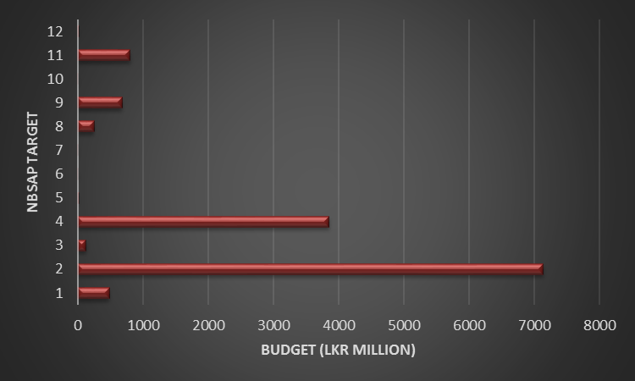
Figure 3.1: Comparison of Finance Needs for the 12 NBSAP Targets

In order to assist in the effective allocation of resources, the finance needs of the 87 NBSAP actions (of the 12 NBSAP targets) were given an identification number (Annex 4) and estimated according to high, medium and low priority (Table 3.2). The analysis demonstrates that majority of the financial need is in high or medium priority. For instance, only 3% of costs have been identified as low priority (Figure 3.2).

Table 3.2: Finance needs according to the prioritisation of NBSAP actions
NBSAP Action Identification Number | Cost in LKR Millions
NBSAP Action Identification Number | Low | Medium | High
2.4, 2.6, 2.12, 3.6, 5.4, 8.1, 8.2, 8.3, 9.4, 10.4, 11.2 and 12.5 | 318.46
1.4, 1.5, 1.6, 1.7, 1.8, 1.9, 2.2, 2.5, 2.7, 2.10, 2.11, 2.16, 3.2, 3.5, 3.7, 4.2, 4.6, 4.7, 4.8, 4.9, 4.10, 5.1, 5.2, 5.5, 5.6, 5.7, 6.4, 6.5, 7.1, 7.2, 7.3, 7.4, 7.6, 8.4, 8.6, 9.1, 9.2, 9.3, 9.5, 10.1, 10.2, 10.3, 10.5, 11.5, 12.1, 12.2, 12.3, 12.4 and 12.6 |  | 5,143.57
1.1, 1.2, 1.3, 2.1, 2.3, 2.8, 2.9, 2.13, 2.14, 2.15, 3.1, 3.3, 3.4, 4.1, 4.3, 4.4, 4.5, 5.3, 6.1, 6.2, 6.3, 7.5, 8.5, 11.1, 11.3 and 11.4 |  |  | 7,975.02

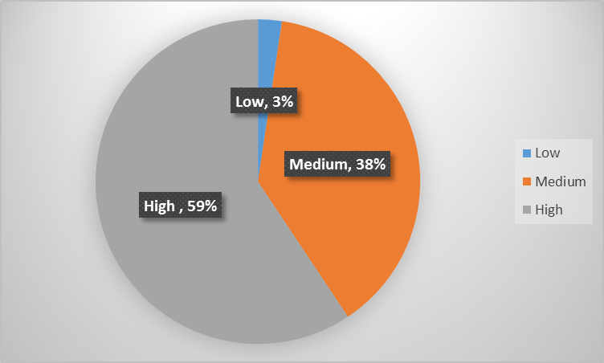
Figure 3.2: Percentage of the Cost of NBSAP Actions According to Prioritization
The biodiversity priority and cost comparisons related to NBSAP Actions are presented in three separate figures to easily demonstrate the contrast (Figure 3.3 to 3.5). The analysis is useful in identifying ‘high priority, low cost’ to ‘low priority, high cost’ actions to inform implementation depending on resource availability. For instance, NBSAP action 6.3 and 6.2 would be cost effective in achieving biodiversity conservation goals as it falls into the category of high priority, low cost (Figure 3.3). On the other hand, NBSAP action 8.2 may not permit effective conservation as it falls into the category low priority, high cost (Figure 3.4).
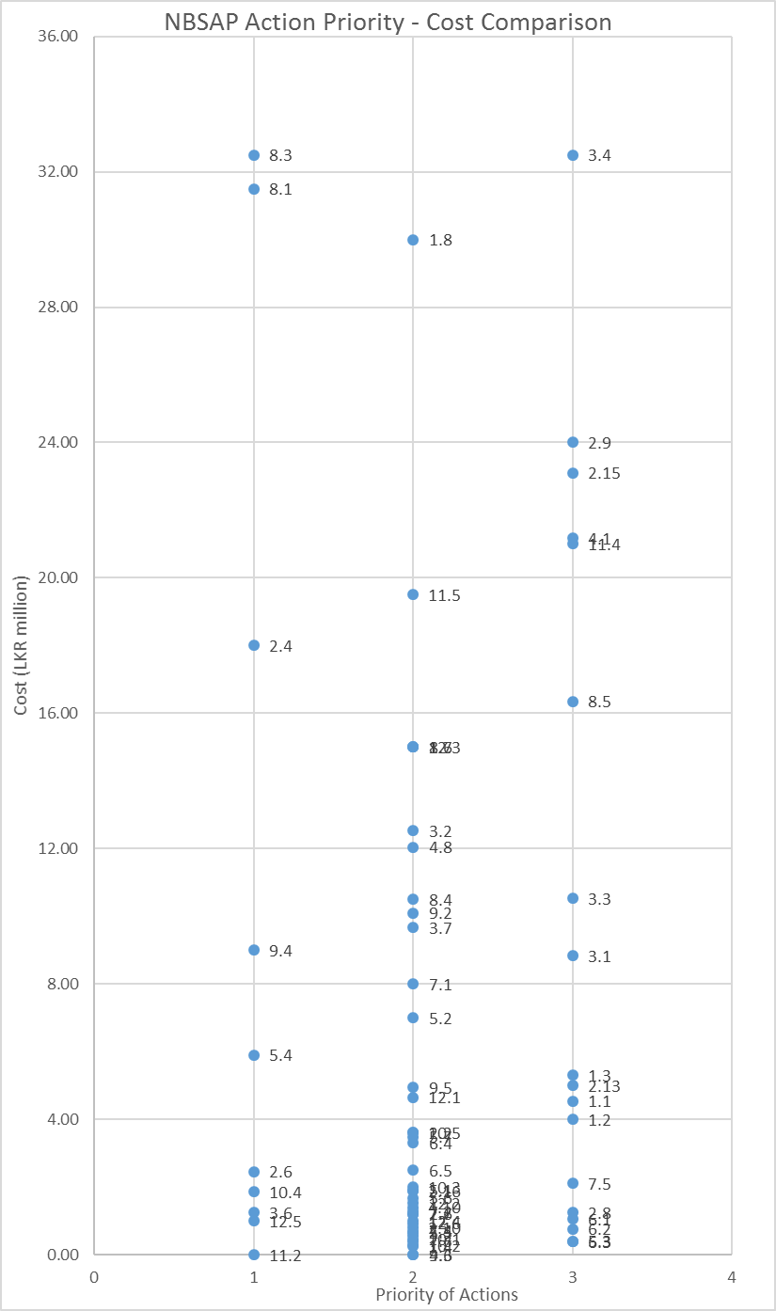
Figure 3.3: Comparison of priority of NBSAP Actions (Low=1, Medium=2, High=3) with cost of NBSAP actions (LKR 0 – 50 million)
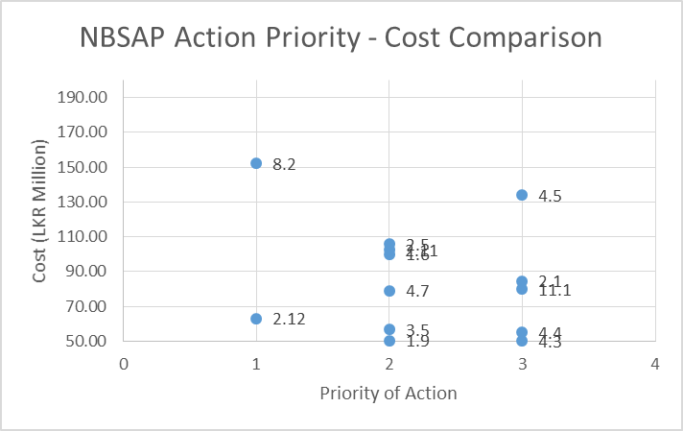

Figure 3.4: Comparison of priority of NBSAP Actions (Low=1, Medium=2, High=3) with cost of NBSAP actions (LKR 50 - 200 million)

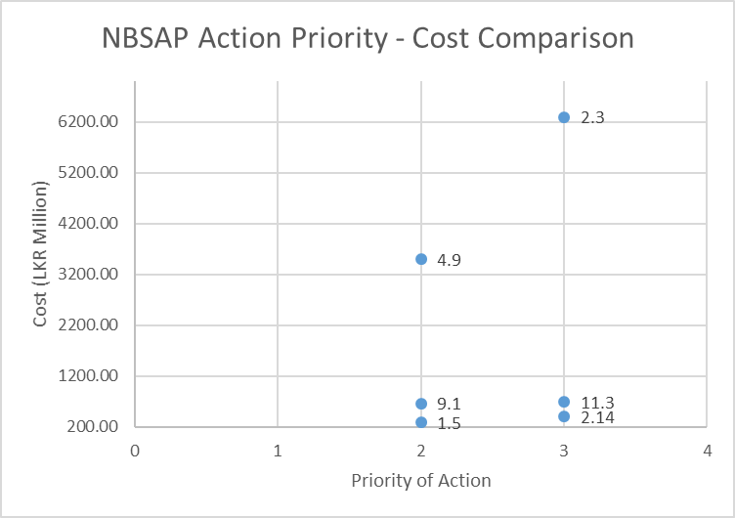
Figure 3.5: Comparison of priority of NBSAP Actions (Low=1, Medium=2, High=3) with cost of NBSAP actions (LKR 200 – 7000 million)
The NBSAP actions were sorted according to the nine BIOFIN categories in Excel and the finance needs for each category were analysed (Table 3.3). Results indicate that the BIOFIN category ‘sustainable use’ has the highest financial need with ‘pollution management’ and ‘access and benefit sharing’ categories coming in second and third respectively (Table 3.3). This analysis will be useful in comparing local costs of a particular category with that of another BIOFIN country/ies.

Table 3.3: Financial Needs for Biodiversity Conservation According to BIOFIN categories
BIOFIN Category | Annual Cost (in million LKR)
BIOFIN Category | 2018 | 2019 | 2020 | 2021 | 2022 | 2023 | 2024 | Category Total
1. Access and Benefit Sharing (ABS) | 16.17 | 30.13 | 226.69 | 210.27 | 215.03 | 208.44 | 201.15 | 1,107.87
2. Biodiversity awareness and knowledge | 0.00 | 0.58 | 0.38 | 0.38 | 0.38 | 1.22 | 1.22 | 4.13
3. Biosafety | 2.81 | 50.94 | 32.80 | 4.80 | 4.80 | 4.80 | 4.80 | 105.75
4. Green economy | 11.15 | 41.70 | 76.00 | 71.05 | 53.10 | 33.25 | 6.50 | 292.75
5. Biodiversity and development planning | 0.85 | 6.05 | 25.50 | 24.30 | 24.50 | 24.30 | 24.30 | 129.80
6. Pollution management | 26.11 | 1209.00 | 1204.66 | 692.55 | 695.48 | 647.70 | 134.60 | 4,610.09
7. Protected areas and other conservation measures | 0.00 | 15.00 | 28.00 | 198.45 | 180.45 | 160.45 | 160.45 | 742.80
8. Restoration | 2.03 | 0.78 | 3.42 | 10.58 | 10.86 | 4.50 | 0.53 | 32.68
9. Sustainable use | 6.05 | 29.78 | 26.69 | 2533.69 | 3036.95 | 388.94 | 389.08 | 6,411.18
Annual Total | 65.17 | 1,383.95 | 1,624.14 | 3,746.05 | 4,221.54 | 1,473.60 | 922.62 | 13,437.05

In addition, the NBSAP actions were sorted according to Aichi targets in Excel and costs per Aichi target were estimated (Table 3.4). It was found that financial needs according to Aichi target number 15 and 12 are the highest (Figure 3.3). It was also noted that there were several NBSAP actions that did not come under any Aichi target, and the financial need for these actions is LKR 30.54 million. This analysis will be useful in reporting to CBD on Aichi Targets and attracting funding specifically allocated for given Aichi target/s.

Table 3.4: Finance needs according to Aichi Targets
Aichi Target (Number) | Annual Cost(LKR Million)
Aichi Target (Number) | 2018 | 2019 | 2020 | 2021 | 2022 | 2023 | 2024 | Category Total
1 | 0.55 | 4.95 | 6.00 | 2.95 | 1.40 |  |  | 15.85
2 |  |  |  | 0.45 | 0.45 | 2.13 | 2.13 | 5.16
3 | 1.05 | 0.28 | 0.39 | 0.34 | - | - | 0.14 | 2.20
4 | 0.70 | 12.35 | 7.25 | 7.25 | 7.25 | - | - | 34.80
5 | - | 32.18 | 34.78 | 44.59 | 50.65 | 6.38 | 6.38 | 174.94
6 | 0.65 | 1.75 | 0.50 | 0.70 | 0.10 | - | - | 3.70
7 | 4.00 | 17.50 | 42.50 | 38.85 | 38.50 | 26.00 | 1.00 | 168.35
8 | 2.81 | 50.94 | 40.80 | 14.80 | 4.80 | 4.80 | 4.80 | 123.75
9 | 0.85 | 6.05 | 25.50 | 24.30 | 24.50 | 24.30 | 24.30 | 129.80
10 | - | 2.50 | 82.50 | 80.00 | 80.00 | 80.00 | 80.00 | 405.00
11 | 13.66 | 55.16 | 37.32 | 12.90 | 5.78 | 5.10 | 2.00 | 131.91
12 | 14.09 | 1,038.69 | 1,061.39 | 561.15 | 559.65 | 542.44 | 25.15 | 3,802.56
13 | 6.75 | 105.10 | 108.35 | 111.30 | 117.30 | 114.10 | 114.10 | 677.00
14 | 5.00 | 29.50 | 25.00 | 191.05 | 176.55 | 150.60 | 150.60 | 728.30
15 | - | 5.00 | 17.15 | 2,528.45 | 3,031.50 | 401.50 | 401.50 | 6,385.10
16 | 0.23 | 0.23 | 0.27 | 2.00 | 1.86 | 2.10 | - | 6.68
17 |  |  |  |  |  |  |  | -
18 | 6.60 | 8.50 | 4.65 | 1.45 | 0.50 | - | - | 21.70
19 | 3.43 | 11.76 | 126.07 | 114.95 | 111.75 | 111.75 | 110.00 | 589.71
20 |  |  |  |  |  |  |  | -
No Target Assigned | 4.80 | 1.52 | 3.72 | 8.58 | 9.00 | 2.40 | 0.53 | 30.54
Annual TOTAL | 65.17 | 1,383.95 | 1,624.14 | 3,746.05 | 4,221.54 | 1,473.60 | 922.62 | 13,437.05

Figure 3.6: Distribution of Financial Needs According to Aichi Targets
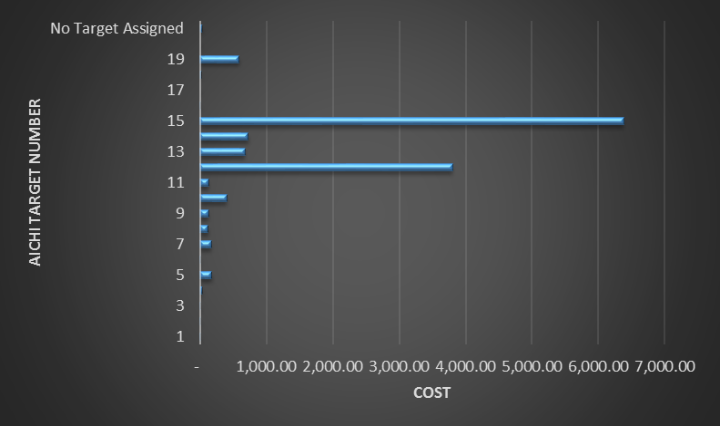

The NBSAP has identified primary and secondary institutions responsible for the implementation of its actions and targets, and during the FNA workshop this was reviewed and improved by the participants in the group work process. The IUCN BIOFIN team was then able to categorise the financial needs for NBSAP according to the main institution responsible (Table 3.5). From the results it can be deduced the institution with most responsibility of NBSAP actions are the DWC and FD. Details related to agency responsibilities and budgets are provided in the FNA Excel work book provided electronically (sample is given in Annex 5).

Table 3.5: Financial Needs According to Key Agencies
Agency Name | Annual budget (in million LKR)
Agency Name | 2018 | 2019 | 2020 | 2021 | 2022 | 2023 | 2024 | Total
1. Biodiversity Secretariat, Ministry of Mahaweli Development and Environment | 23.40 | 22.48 | 135.27 | 139.90 | 130.28 | 128.13 | 116.94 | 696.40
2. DWC – Department of Wildlife Conservation | 14.86 | 56.39 | 81.66 | 1327.80 | 1571.56 | 230.87 | 198.77 | 3,481.91
3 FD – Forest Department | 1.20 | 19.04 | 20.92 | 1299.10 | 1545.66 | 226.52 | 226.52 | 3,338.96
4. DNZG – Department of National Zoological Gardens | 2.85 | 542.03 | 542.96 | 294.96 | 298.30 | 298.07 | 45.57 | 2,024.74
5. DNBG – Department of National Botanic Gardens | 0.60 | 539.78 | 540.96 | 290.86 | 294.20 | 293.97 | 41.47 | 2,001.84
6. CEA – Central Environment Authority | 3.41 | 71.23 | 55.29 | 28.10 | 31.10 | 10.80 | 10.80 | 210.73
7. DFAR – Department of Fisheries and Aquatic Resources | 0.15 | 0.70 | 0.25 | 0.32 | 0.03 | 0.00 | 0.00 | 1.45
8. CC&CRMD – Coast Conservation and Coastal Resources | 0.00 | 14.50 | 14.60 | 57.19 | 54.09 | 30.09 | 30.09 | 200.56
9. NPQS – National Plant Quarantine Service (DoA) | 0.00 | 0.13 | 0.00 | 0.00 | 0.00 | 0.00 | 0.00 | 0.13
10. PGRC – Plant Genetic Resources Centre (DoA) | 7.00 | 56.68 | 99.81 | 98.08 | 84.62 | 68.92 | 39.92 | 455.03
11. DAPH – Department of Animal Health and Production | 2.35 | 4.33 | 2.75 | 1.25 | 1.25 | 0.00 | 0.00 | 11.93
12. DoEA – Department of Export Agriculture | 0.00 | 0.00 | 0.00 | 0.00 | 0.20 | 0.00 | 0.00 | 0.20
13. NARA – National Aquatic Resources Research and Development Agency | 1.15 | 9.30 | 7.50 | 7.47 | 7.43 | 5.63 | 3.13 | 41.61
14 MASL – Mahaweli Authority SL | 0.00 | 3.00 | 3.10 | 37.19 | 34.09 | 30.09 | 30.09 | 137.56
15. Other agencies | 8.20 | 44.37 | 149.06 | 163.84 | 168.74 | 149.51 | 149.33 | 833.05
Annual total budget | 65.17 | 1,383.95 | 1,654.14 | 3,746.05 | 4,221.54 | 1,472.60 | 892.62 | 13,436.07
When considering the finance needs of the other three strategies (NRIFAP, NAP-CC, NAP-CLD), the costs per component/activity have already been estimated. However, the BIOFIN team in a consultative process (as mentioned above) selected the biodiversity relevant expenditure from the three strategies, and estimated the total cost as well as the annual cost for all three strategies. With regard to the NRIFAP, all components were identified as biodiversity relevant expenditure (Table 3.6). The total incremental finance needs for NRIFAP is Sri Lankan Rupees 14.88 billion, which is greater than the NBSAP implementation cost by Sri Lankan Rupees 1.45 billion. Relatively high costs in NRIFAP can be partly attributable to the identified modality of engagement of multiple UN agencies with international consultancies as against mostly locally implemented NBSAP actions.

Table 3.6: National REDD+ Investment Framework and Action Plan
National REDD+ Investment Framework and Action Plan
Components | Annual Costs (LKR millions) (1 USD = 150 LKR) |  |  |  |  | Total Cost (LKR)
Components | 2018 | 2019 | 2020 | 2021 | 2022 | Total Cost (LKR)
Implementation of REDD+ Policies and Measures (PAMs) | 1,827.86 | 2,394.60 | 2,390.24 | 2,370.48 | 2,355.77 | 11,338.95
NRIFAP Coordination and Capacity Building of Key Institutions | 321.47 | 243.09 | 219.71 | 194.48 | 216.54 | 1,195.29
Safeguards and Safeguards Information System | 54.25 | 51.77 | 67.02 | 51.77 | 67.65 | 292.46
National forest monitoring system and forest reference level | 347.00 | 371.87 | 343.17 | 183.22 | 130.91 | 1,376.16
Stakeholder engagement in NRIFAP implementation | 62.86 | 59.28 | 59.28 | 65.25 | 53.32 | 300.00
Communication and Knowledge Management | 42.75 | 31.00 | 39.50 | 31.00 | 42.00 | 186.25
Grievance Redress Mechanisms | 23.30 | 56.96 | 42.75 | 38.25 | 33.75 | 195.01
TOTAL | 2,679.49 | 3,208.58 | 3,161.68 | 2,934.45 | 2,899.93 | 14,884.13

The National Adaptation Plan for Climate Change (NAP-CC) was similarly considered for the FNA process, and the cost estimates for the biodiversity relevant components (or ‘adaptation need’) were selected (Table 3.7). The total incremental finance needs required for the achievement of biodiversity conservation as outlined in the NAP-CC is for 2018-2024 period therefore is LKR 501 million.

Table 3.7: National Adaptation Plan for Climate Change - Ecosystems and Biodiversity Budget
National Adaptation Plan for Climate Change - Ecosystems and Biodiversity Budget
Adaptation Need | Annual Costs (LKR Million) |  |  |  |  |  |  | Total Proposed Budget  (Rs. Million)
Adaptation Need | 2018 | 2019 | 2020 | 2021 | 2022 | 2023 | 2024 | Total Proposed Budget  (Rs. Million)
Enhance the resilience of natural and agro ecosystems against the impacts of climate change impacts | 78.00 | 77.00 | 41.00 | 39.00 | 39.00 | 37.00 | 35.00 | 346.00
Enhance the resilience of natural and agro ecosystems against extreme weather events | 12.00 | 12.00 | 9.00 | 7.00 | 7.00 | 5.00 | 5.00 | 57.00
Minimize the impacts of sea level rise on coastal bio-diversity and ecosystem services | 5.00 | 5.00 | 5.00 | 5.00 | 5.00 | 5.00 | 5.00 | 35.00
Assess the changes in oceanic environment and impacts on livelihoods and food security | 4.00 | 4.00 | 4.00 | 4.00 | 4.00 | 4.00 | 4.00 | 28.00
Assess the impacts of rising atmospheric CO2 on biomass production of natural vegetation and spread of invasive alien species | 5.00 | 5.00 | 5.00 | 5.00 | 5.00 | 5.00 | 5.00 | 35.00
TOTAL | 104.00 | 103.00 | 64.00 | 60.00 | 60.00 | 56.00 | 54.00 | 501.00

The same process was conducted with the National Action Plan to Combat Land Degradation (NAP-CLD), in which biodiversity related actions/programs were selected for the FNA (Table 3.8). The total incremental finance needs estimated for the NAP-CLD is therefore LKR 1.89 billion.

Table 3.8: Biodiversity related cost estimate of the National Action Programme to Combat Land Degradation
National Action Plan to Combat Land Desertification
Total Budget (Rs. Million) | Annual Budget (LKR Million)
Total Budget (Rs. Million) | 2018 | 2019 | 2020 | 2021 | 2022 | 2023 | 2024
Program 4 - Incorporation of SLM programs in poverty reduction programs
3.50 | 0.50 | 0.50 | 0.50 | 0.50 | 0.50 | 0.50 | 0.50
Program 10: Promotion of Biodiversity conservation for improvement of degraded ecosystems
25.90 | 2.95 | 3.20 | 3.95 | 3.95 | 3.95 | 3.95 | 3.95
Program 11: Preventing forest cover decline
1,234.50 | 188.50 | 188.50 | 171.50 | 171.50 | 171.50 | 171.50 | 171.50
Program 12: Restoration of degraded forests
604.45 | 87.85 | 86.60 | 86.00 | 86.00 | 86.00 | 86.00 | 86.00
Program 13: Conservation of grasslands (Pathana, Savana, Damana and Villu)
8.86 | 2.17 | 0.84 | 1.17 | 1.17 | 1.17 | 1.17 | 1.17
Program 21: Prevention of coastal erosion to reduce loss of land and rehabilitation of degraded coastal areas
14.00 | 2.00 | 2.00 | 2.00 | 2.00 | 2.00 | 2.00 | 2.00
Total
1891.21 | 283.97 | 281.64 | 265.12 | 265.12 | 265.12 | 265.12 | 265.12

A summary of all four strategies depicts the total incremental finance needs required for meeting biodiversity conservation goals in Sri Lanka for the time period 2018 – 2024 (Table 3.9). The total incremental financial need is LKR 30.71 billion, which is 0.26% of the GDP in current prices (Central Bank, 2017).

Table 3.9: Financial Needs for Biodiversity Conservation According to All Strategies
Strategy | Annual budget (in million LKR)
Strategy | 2018 | 2019 | 2020 | 2021 | 2022 | 2023 | 2024 | Total
NBSAP | 65.17 | 1,383.95 | 1,624.14 | 3,746.05 | 4,221.54 | 1,473.60 | 922.62 | 13,437.07
NRIFAP | 2,679.49 | 3,208.58 | 3,161.68 | 2,934.45 | 2,899.93 |  |  | 14,884.13
NAP-CLD | 283.97 | 281.64 | 265.12 | 265.12 | 265.12 | 265.12 | 265.12 | 1,891.21
NAP-CC | 104.00 | 103.00 | 64.00 | 60.00 | 60.00 | 56.00 | 54.00 | 501.00
Total | 3,132.63 | 4,977.17 | 5,114.94 | 7,005.62 | 7,446.59 | 1,794.72 | 1,241.74 | 30,713.41

Figure 3.7: Relative Costs of Biodiversity Strategies

The results of the NBSAP financial needs is further categorized according to the type of costs required (recurrent or capital costs) and the time period (short term or medium term) (Table 3.10). This would assist in the allocation of resources and the development of the biodiversity finance plan of BIOFIN. The results indicate that the recurrent costs for NBSAP (LKR 9,216.49 million) are much higher than the capital costs, at 68% of the total NBSAP cost (Table 3.10).

Table 3.10: Financial Needs according to cost category and timing
Time Period | Annual budget (in million LKR)
Time Period | Recurrent | Capital | Total
NBSAP
1. Short term (2018 and 2019) | 292.62 | 1,156.50 | 1,449.12
2. Medium Term (2020-2025) | 8,923.87 | 3,064.07 | 11,987.94
Total | 9,216.49 | 4,220.57 | 13,437.05

The results of the FNA component of BIOFIN Sri Lanka estimated the incremental (or additional) costs needed to implement the four plans and programmes identified. In the costing exercise of these four plans/programmes, the business-as-usual or baseline biodiversity conservation expenditure was not included. Hence, the results of the FNA can be taken as the financing gap for meeting the biodiversity targets set for 2024. The total FNA can be estimated by adding current FNA estimates to baseline biodiversity expenditure as estimated by the BER for Sri Lanka.

Table 3.11: Incremental FNA, total FNA and Financing Gap (to be prepared when BER is finalized)
Strategy | Annual Amount (in million LKR)
Strategy | 2018 | 2019 | 2020 | 2021 | 2022 | 2023 | 2024 | Total
FNA (incremental)
Baseline costs from BER
FNA (total)
Financing Gap

Conclusions and Recommendations
The finance needs assessment for BIOFIN Sri Lanka was successful in understanding the costs required for the achievement of biodiversity conservation goals in the country. This assessment found that the financial resources required for four key plans/programmes to be implemented in the country during the time period 2018 – 2024 is LKR 30.71 Billion. The main document costed and reviewed throughout the entire FNA process was the NBSAP, as key stakeholders and the BIOFIN team noted its importance in biodiversity conservation. However emphasis was also placed on the NRIFAP, the NAP-CC and the NAP-CLD as key plans/programmes for review. While the assessment incorporated national biodiversity conservation plans at the higher government/donor level, there is little to no sub-level plans for biodiversity conservation in Sri Lanka and therefore these were not incorporated. Since these four plans are comprehensive and widespread in its biodiversity outcomes and involves stakeholders over a wide range of institutions, the consideration of other strategies may result in an overlap of costing.
In assessing the financial need for the NBSAP an activity based costing approach (UNDP, 2016) was used, in which a working group with key stakeholders costed the actions of the 12 national targets. This approach was useful in the FNA process as it incorporated the detailed actions for each target and enabled the quantification of the actions (UNDP, 2016). Due to the detailed costing already available in the other three plans, stakeholder were engaged in identifying which activities were biodiversity related and these were incorporated into the analysis. One of the strengths of the FNA process is the level of stakeholder engagement maintained throughout the study. The increased involvement and maintenance of communication with participants of the working group meetings led to a more robust study.
After the costing exercise of the national plans it was realised that the FNA reflected additional costs required for achieving conservation goals and did not take into account baseline costs such as recurrent costs (salaries, maintenance etc.). Although it may seem as this is a limitation of the study it does not affect the main objectives of the entire BIOFIN process. The only challenge would be to re-word the terminology or alter one’s view of the components. In this assessment, the FNA ended up being the finance gap of BIOFIN and in order to obtain the real FNA for the country, the BER figures needed to be added. This change in terms does not alter the overall aim of BIOFIN in developing a finance plan for biodiversity in Sri Lanka.
The results of this assessment is vital in understanding how financial resources can be re-allocated and new finances generated for the achievement of the national plans. Although this report provides an insight into the information generated from this exercise, the electronically available workbook provides a more detailed analysis which can be tailored to the research need or question regarding financial needs for biodiversity in Sri Lanka. For instance, if an institution such as DWC or FD is interested in understanding the financial resources they require for achieving NBSAP targets, this information can be extracted from the workbook. Similarly, information for policy decisions regarding Aichi targets can be found in this workbook. The prioritisation-cost matrix is extremely helpful in suggesting areas of immediate funding and/or can inform funding and planning decisions, and the BIOFIN categories allow determining which themes/sectors across biodiversity require more funding. This analysis is therefore extremely useful in proceeding to the next steps of BIOFIN and in developing the biodiversity finance plan for Sri Lanka.

The biodiversity financing needs assessment for Sri Lanka was prepared based on four sources of information. As these incremental FNA figures are without baseline, they are the financing gaps for meeting national biodiversity targets set. Therefore, the total FNA is taken as the sum of incremental FNA estimated and the baseline biodiversity expenditure estimated in BER, which comes to LKR billions xxxx.
With the guidance of the BIOFIN Workbook, the FNA for Sri Lanka accomplished the task through sound methodological approach and working with the right timing, format and partners. The key partners in FNA included the ministry of finance, ministry of environment, planning agencies and other key stakeholders in biodiversity as identified in the PIR process. Hence, the estimates will have a better likelihood of full funding.
Financial needs identified should be taken as investment in biodiversity as sustaining biodiversity will contribute immensely to direct and indirect ecosystem services that they provide. Some of these are identified in Environmental Economic Valuation Review (EEVR) conducted as part of IUCN inputs to BIOFIN in Sri Lanka which will be useful in identifying financing plan for conserving biodiversity in Sri Lanka as the next step in BIOFIN.

References
Annual Report 2016 (2017), Central Bank of Sri Lanka, Colombo
Ministry of Finance and Planning (2017). Budget Estimates 2017. Vol. 1 - 3. Colombo: Ministry of Finance and Planning
Ministry of Mahaweli Development and Environment (2016a). National Biodiversity Strategic Action Plan 2016-2022. Colombo, Sri Lanka: Biodiversity Secretariat, Ministry of Mahaweli Development and Environment
Ministry of Mahaweli Development and Environment (2016b). National Adaptation Plan for Climate Change Impacts in Sri Lanka 2016-2025. Colombo, Sri Lanka: Climate Change Secretariat, Ministry of Mahaweli Development and Environment
Sri Lanka UN-REDD Programme (2017). National REDD+ Investment Framework and Action Plan. Colombo, Sri Lanka: Sri Lanka UN-REDD Programme
UNDP (2016). The 2016 BIOFIN. Workbook: Mobilizing resources for biodiversity and sustainable development. The Biodiversity Finance Initiative. New York: United Nations Development Programme

Annexes

Annex 1: Structure of the IUCN Team

The IUCN team was contracted to assist UNDP BIOFIN project specifically on Biodiversity Expenditure Review (BER), Financial Needs Assessment (FNA) and Environmental Economic Valuation Review (EEVR) and to provide inputs to the Biodiversity Finance Plan. Due to time constraints in implementing BIOFIN Sri Lanka, the IUCN team were tasked to begin BER, FNA and EEVR components simultaneously and completed all the drafts in the period August – December 2017. Contract duration extended till end January 2018 to accommodate the National Workshop for BER and FNA validation.
The IUCN team for the BIOFIN project comprised of a mix of experts, junior consultants, research assistants and interns with a wide area of knowledge including environmental economics and policy (Box 1). The members of the junior team changed during the project period, however at any given time there were five junior members present to assist the experts. In addition to the team mentioned above, Mrs. Sudharma Karunaratne, Chairperson of the NIBM and former Director General Department National Budget assisted in facilitating meetings with key National and Subnational stakeholders. Dr. Ananda Mallawatantri, Country Representative, IUCN also provided similar assistance relating to Donor and NGO coordination for BER. Professor K. Amirthalingam provided inputs to BER and both the BER and FNA components were reviewed and guided by Prof. Sirimal Abeyratne, Lead Consultant, BIOFIN Sri Lanka.
Box 1: The IUCN BIOFIN Team
Team Leader BIOFIN IUCN Component: Shamen Vidanage

BER
Lead Expert: Dr. Athula Senaratne
FNA
Lead Expert: Shamen Vidanage
EEVR
Lead Expert: Dr. Prasanthi Gunawardene

Junior Consultants: Radheeka Jirasinha, Sampath Bandara, Christina Semasinghe, Chamathi Jayaratne, Sujitha Chathurangi
Research Assistant: Chameli Liyanage
Intern: Asanga Muthuwatta

Annex 2: List of Stakeholders Consulted

Institution | Name | Designation | Stakeholder Consultation 8th Sep 2017 | FNA Working Group Meeting  6-7th Nov 2017 | Validation Workshop 22nd January 2018
Sri Lanka Customs | G. Sarath Kumara | Finance Director |  | ✓
Sri Lanka Customs | P. Wijenayake | DSC |  | ✓
DNBG | H.G. Jayasekara | ADP |  | ✓
DNBG | E.M.S. Ekanayake | PA |  | ✓
DNBG | Nadeeka Gunawardana | AMO | ✓
Ministry of Agriculture | T.H. Amarasinghe | Director |  | ✓
Ministry of Agriculture | D. Weerakoon | Dean Faculty of Nursing, University of Colombo |  | ✓
MOMD&E | K.K.D.K. Gunarathne |  |  | ✓
MOMD&E | H. Gamage | Research Assistant |  | ✓
MOMD&E | Ajith Silva | Director/Land Resources |  | ✓
MOMD&E | G.K.H. Madushani | Assistant Director | ✓ | ✓
MOMD&E | D. Upul Premalal | Research Assistant | ✓ | ✓
MOMD&E | Sepali de Silva | Assistant Director | ✓ | ✓
MOMD&E | M.A. Chanuka Maheshani | Research Assistant | ✓ | ✓
MOMD&E | K.P. Premathilake |  |  | ✓
MOMD&E | W.P.S.D. Pathirana | Assistant Director |  | ✓
MOMD&E | Rupika Bakmeedeniya | Assistant Director |  | ✓
MOMD&E | Nilmini Ranasinghe | Assistant Director | ✓ | ✓
MOMD&E | Piumi Bentarage | Assistant Director |  | ✓
MOMD&E | Hemamali Herath | Research Assistant | ✓ | ✓
MOMD&E | R.H.M.P. Abeykoon |  | ✓ | ✓
MOMD&E | N.D. Wickramaarachchi | Assistant Director |  | ✓
MOMD&E | Himali de Costa | Assistant Director | ✓
BACC Project | A.S.K. Liyanage | NPC |  | ✓
SLLRDC | K.V.S.N. Bandara | Environment Officer |  | ✓
DNZG | P. Bandaranayake | Deputy Director |  | ✓
DNZG | H.A. Anoma Priyadarshani | Deputy Director | ✓ | ✓
NAQDA | H.M.U.K.P.B. Herath | Director |  | ✓
DFAR | M.P.P. Sandaru | Fisheries Officer |  | ✓
DFAR | W.G. Inoka Lakshmi | Development Officer |  | ✓
DFAR | M.M. Ariyarathna | Assistant Director | ✓
PGRC/DOA | G. Samarasinghe |  |  | ✓
PGRC/DOA | S.M.S.W. Wanigadeva | ADA (Research) |  | ✓
DAPH | K.D. Ariyapala | Director | ✓ | ✓
DAPH | M.D.P.S. Wijegunarathne | Livestock Officer |  | ✓
DEA | W.M.R.W.B. Weerakoon | Deputy Director |  | ✓
DEA | M.K.S.R.D. Samarasinghe | Deputy Director (Research) |  | ✓
CEA | T.M.A.S.K. Rodrigo | Director | ✓
CEA | R.A.C.H. Wijayasinghe | Director Planning |  | ✓
Forest Department | N.D.R. Weerawardana | ADCGF |  | ✓
NARA | A.A.D. Amaratunga | Senior Scientist |  | ✓
NARA | Ramani Shirantha | Senior Scientist | ✓
DWC | Eranda Gamage | Assistant Director (NRM) |  | ✓
DWC | Shantha Weerasingha | Assistant Director(L/E) |  | ✓
NPQS | I.K. Warshamana | Deputy Director |  | ✓
NPQS | W.J. Nimanthika | Assistant Director |  | ✓
MEPA | S.M.D. Athukorala | Assistant Environment Officer |  | ✓
CC & CRMD | K.H. Ruwan Sriyantha | Assistant Director |  | ✓
MASL | N.S. Amarasinghe | Landuse Planner |  | ✓
MASL | J.M.I.H. Jayaweera | Assistant Director LUP | ✓
Ministry of Sustainable Development and Wildlife | M.M.S.S.B. Yalegama | Addl Secretary | ✓
MPL | J.A. Ranjith | Secretary | ✓
Janathakshan | Asitha Wewaldeniya | Manager Disaster Risk Reduction and Climate Change Adaptation | ✓
Green Media | Lalith Ekanayake |  | ✓
Green Media | Dumindu Balasuriya |  | ✓
National Chamber of Commerce of Sri Lanka | Krishani Fonseka | Manager – Finance & Personel | ✓
Green Movement of Sri Lanka | Upul Jayathilaka | Programme Manager | ✓
USIP | C.T. Jayaratne | Temporary Lecturer | ✓
USIP | P. Gunawardena | Senior Lecturer | ✓
NIE | Jayanthi Gunasekara | Director General | ✓
SLNG | Thilak Kariyawasan | ED | ✓
PILF | Sonali de Silva | Chairperson | ✓
NSF | S.M.A. Wasantha Anuruddha | Principal Scientific Officer | ✓
NSF | H.A.U. Amarasinghe | MAB | ✓
EFL | Eric Wikramanayake | Chair | ✓
Sudeesa | Prof. Herath | Professor | ✓
Biodiversity Sri Lanka | S.E. Yasaratne | Advisor | ✓
NPPD | K. Sugirthan | Planner | ✓
Department of National Budget | Ms. Geetha Wimalaweera, | Additional Director General, | 28/09/2017 | Separate meeting

Annex 3: Expenditure Classification by Department of National Budget

Object Code | Object Category/Title
Recurrent Expenditure
 | Personal Emoluments
1001 | Salaries and Wages
1002 | Overtime and Holiday Payments
1003 | Other Allowances
 | Travelling Expenses
1101 | Domestic
1102 | Foreign
 | Supplies
1201 | Stationery and Office Requisites
1202 | Fuel
1203 | Diets and Uniforms
1204 | Medical Supplies
1205 | Other
 | Maintenance Expenditure
1301 | Vehicles
1302 | Plant and Machinery
1303 | Buildings and Structures
 | Services
1401 | Transport
1402 | Postal and Communication
1403 | Electricity and Water
1404 | Rents and Local Taxes
1406 | Interest Payment for Leased Vehicles
1407 | Capital Carrying Coast pf Government – Lands & Buildings
1408 | Lease Rental for Vehicle Procurred Under Operational Leasing
1409 | Other
 | Transfers
1501 | Welfare Programmes
1502 | Retirement Benefits
1503 | Public Institutions
1504 | Development Susbsidies
1505 | Subscriptions and Contribution Fee
1506 | Property Loan Interest to Public Servants
1507 | Grants to Provicial Councils
1508 | Other
1509 | Contribution to Contingencies Fund
 | Interest Payments and Discounts
1601 | Interest Payment for Domestic Debt
1602 | Interest Payment for Foreign Debt
1603 | Discounts on Treasury Bills and Treasury Bonds
 | Other Recurrent Expenditure
1701 | Losses and Write Offs
1702 | Contingency Services
1703 | Implementation of the Official Languages Policy
Capital Expenditure
 | Rehabilitation and Improvement of Capital Assets
2001 | Buildings and Structures
2002 | Plant, Machinery and Equipment
2003 | Vehicles
 | Acquisition of Capital Assets
2101 | Vehicles
2102 | Furniture and Office Equipment
2103 | Plant, Machinery and Equipment
2104 | Buildings and Structures
2105 | Land and Land Improvments
2106 | Software Development
2018 | Capital Payment for Leased Vehicles
 | Capital Transfers
2201 | Public Institutions
2202 | Development Assistance
2203 | Gants to Provincial Councils
2204 | Transfers Abroad
2205 | Captial Grants to Non-Public Institutions
 | Acquisition of Financial Assets
2301 | Equity Contribution
2302 | On-Lending
 | Capacity Building
2401 | Staff Training
 | Other Capital Expenditure
2501 | Restructuring
2502 | Investments
2503 | Contingency Services
2504 | Contribution to Provincial Councils
2505 | Procurement Preparedness
2506 | Infrastructure Development
2507 | Research and Development
2509 | Other

Annex 4: List of NBSAP Actions

Number | Target / Action description
Target 1 | By 2022, a system established and ongoing for inventorying species (taxonomy conservation status), ecosystems (structure, function, composition and distribution), their services and values, to inform conservation planning and decision making
1.1 | Establish a national list of species and ecosystem types with annual updating
1.2 | Establish a national biodiversity database to document biodiversity in all natural areas
1.3 | Populate the database with existing data sets and update continuously
1.4 | Develop a research agenda to address identified information gaps on sites, taxa and valuation of ecosystem services and share this information with relevant stakeholders
1.5 | Establish a national botanical and zoological survey programme to conduct baseline surveys for subsequent monitoring of sites identified in action 4
1.6 | Provide seed grants for contract research on identified sites, taxa and ecosystem services, where information is not presently available
1.7 | Provide training for local experts on lesser known taxa
1.8 | Provide financial support for local experts to communicate their findings related to biodiversity of Sri Lanka both nationally and globally
1.9 | Develop and implement a communication strategy to disseminate the information collected to relevant stakeholders
Target 2 | By 2022, habitat loss, degradation and fragmentation are significantly reduced
2.1 | Conduct Strategic Environment Assessments for all nine provinces and identify the best possible pathway to achieve national development goals with the least amount of habitat loss and fragmentation
2.2 | Develop a national ecosystem (terrestrial, coastal and marine) conservation plan to identify the best possible strategies for afforestation, enhancement, restoration and establishing connectivity, with reference also to ecosystem-based climate change adaptation
2.3 | Implement the national ecosystem conservation plan by integrating it with provincial and local development plans as well as ensuring private sector participation
2.4 | Develop and implement a national programme that reduces reliance on agrochemical usage
2.5 | Develop and implement a national strategy that reduces the release of pollutants and solid waste into wetlands (as defined by Ramsar)
2.6 | Develop and implement of a set of guidelines to reduce the impact of tourism on natural habitats
2.7 | Conduct a national level awareness campaign on invasive alien species and their impacts on natural habitats
2.8 | Strengthen regulatory mechanisms to prevent entry of invasive alien species
2.9 | Establish early warning system for invasive alien species
2.10 | Establish a mechanism for updating National IAS lists every four years
2.11 | Develop and implement species-specific management plans for identified invasive alien species
2.12 | Strengthen the implementation of special management areas, conservation areas and affected areas as defined by the CC&CRM Act
2.13 | Carry out an assessment of species that are undergoing range expansion due to climate change and examine their impacts on ecosystems and develop and implement mitigation measures
2.14 | Carry out a national assessment of the impact of climate change on identified vulnerable species and ecosystems and develop potential mitigation and adaptation strategies and ensure that this assessment feeds into the national adaptation plan for Sri Lanka.
2.15 | Prepare and implement wetland conservation management plans for wetlands that are identified as critical systems lying outside the PA network
2.16 | Preparation of the Red List of Ecosystems for Sri Lanka and updated every five years
Target 3 | By 2022, the PA network is made representative of all critical ecosystems and species and managed effectively
3.1 | Update the protected area gap analysis based on the recommendations of the provincial SEAs and develops and implements a strategy to protect the critical habitats outside the PA network with reference also to ecosystem-based climate change adaptation
3.2 | Conduct a status assessment of the PA network and identify sites that need to be upgraded or downgraded based on their current status
3.3 | Carry out an assessment of the coastal and marine sector and identify and designate the areas that need to be protected and further up scaling of existing and new marine PAs to internationally recognized marine PAs such as Ecologically or Biologically Significant Marine Areas (EBSAs)
3.4 | Establish a marine division in the Department of Wildlife Conservation and implement effective management of MPAs and marine species
3.5 | Prepare adaptive management plans for all areas declared as protected under action 2 and 3 and ensure that these plans are implemented effectively.
3.6 | Protect sites that harbor, key evolutionary links such as fossils or sub-fossils
3.7 | Promote community-based conservation using sui-generis tools for community owned land
Target 4 | By 2022, the loss of species is significantly reduced
4.1 | Update the protected area gap analysis based on the recommendations of the provincial SEAs and develop and implement a strategy to protect the critical habitats outside the PA network with reference also to ecosystem-based climate change adaptation
4.2 | Establish an interactive web portal on threatened species to create awareness on threatened species of Sri Lanka and ensure that this portal is continually updated.
4.3 | Identify research needs with respect to prioritized threatened species and develop a funding mechanism to facilitate such research
4.4 | Develop and implement recovery plans for prioritized threatened species
4.5 | Establish an ex situ breeding and research facility for breeding/ propagation of threatened species under the Department of National Zoological Gardens and National Botanic Gardens
4.6 | Regularize turtle hatcheries with appropriate guidelines for scientific management and a monitoring system established
4.7 | Establish animal care shelters under the Department of Wildlife Conservation for rehabilitation of confiscated, injured and displaced animals in each wildlife region and develop guidelines for reintroduction of rehabilitated species back to the wild
4.8 | Develop and implement species level management plans for mitigation of conflicts caused by threatened species
4.9 | Establish ex situ conservation facilities such as botanic gardens, zoos, aquaria, wetland parks, arboreta, medicinal gardens, urban parks, natural history museums, plant herbaria etc., or upgrade & improve existing facilities in each bioclimatic zone for recreation, conservation, education and research
4.10 | Identify gaps in enforcement of tracking, monitoring and prosecuting illegal trade of scheduled species and update current legislation and regulations to address identified gaps as well as alignment with international conventions such as CITES
Target 5 | By 2022, the valuation of biodiversity is mainstreamed.
5.1 | Conduct programmes to capture and create awareness on value of Biodiversity and Ecosystem Services (BES)
5.2 | Undertake TEEB type valuation studies to determine the value of key ecosystems and their services in Sri Lanka
5.3 | Integrate biodiversity and ecosystem service values in to educational curricula for meaningful engagement
5.4 | Capture and share biodiversity and ecosystem service values embedded in religion and culture
5.5 | Link existing databases and develop and maintain a searchable database/web portal for ecosystems, ecosystem services and their values
5.6 | Integrate biodiversity and ecosystems service values to national accounts
5.7 | Develop guidelines to incorporate Biodiversity and Ecosystem Services values into regional/ national/ local level planning and plan implementation
Target 6 | By 2022, mechanisms are established to ensure sustainable use of biodiversity
6.1 | Develop innovative financing mechanisms to generate sustainable self-financing systems for biodiversity and ecosystem services conservation
6.2 | Introduce appropriate economic instruments for biodiversity and ecosystems conservation
6.2 | Introduce appropriate economic instruments for biodiversity and ecosystems conservation
6.3 | Identify and remove perverse incentives that damage biodiversity and ecosystem services
6.4 | Promote best practices to minimize the destructive harvesting methods used for biological resources from terrestrial, aquatic and marine systems
6.5 | Assess the present levels of harvesting of freshwater and marine finfish/ shell fish and develop and implement recovery plans for finfish/ shell fish species stocks that are depleted due to overexploitation
Target 7 | By 2022, traditional sustainable uses of biodiversity are promoted and established
7.1 | Promote and mobilize cultural practices and traditional wisdom related to biodiversity
7.2 | Establish a searchable database on traditional knowledge, beliefs and practices related to biodiversity
7.3 | promote bio-prospecting of both animal and plant genetic resources through the application of traditional knowledge
7.4 | Develop policy tools for repatriation of traditional knowledge and artifacts which are related to biodiversity and mainstreaming suasive behavior related to biodiversity conservation
7.5 | Introduce an outgrowing system for medicinal plants with the involvement of private sector
7.6 | Identify gaps in Fishery Management Areas (FMA) and implement programs to address the identified gaps
Target 8 | By 2022, sustainable agriculture practices are promoted and established
8.1 | Improve conversion efficiency of raw material to final products
8.2 | Promote and mainstream underutilized, lesser known or neglected food crops, livestock and food fishes which provide nutrition
8.3 | Establish and maintain a searchable database linked with global databases on nutritional quality of food
8.4 | Promote useful elements of traditional knowledge/ practices of unique agro ecosystems (related to such as Kandyan home gardens, cascade tank systems, chena, owita and Mavee lands) to address current issues
8.5 | Identify and conserve useful BES such as natural enemies, pollinators
8.6 | Establish a database on traditional knowledge
Target 9 | By 2022, genetic diversity of crop wild relatives, cultivated species and livestock is conserved
9.1 | Establish and strengthen genetic resource centers such as field gene banks, seed banks etc., for both short and long-term conservation of genetic diversity of crops, poultry and livestock
9.2 | Promote conservation of neglected, lesser known and under-used food crops, livestock and their wild relatives such as vegetables, seeds, fruits, poultry, livestock and food fish
9.3 | Carry out molecular genetics research to identify and use beneficial genes of wild relatives and traditional varieties with aim of improving cultivated crop varieties and animal varieties
9.4 | Implement on-farm conservation for traditional crop varieties and land races and encourage promotion of farmer-based crop varieties and livestock
9.5 | Create new protected areas or special management zones within existing protected areas for in situ conservation of crop wild relatives
Target 10 | By 2022, a mechanism for equitable sharing of benefits arising from biodiversity is established and implemented
10.1 | Enact necessary legislation or amend existing legislation for the smooth implementation of the Nagoya protocol
10.2 | Develop regulations, procedures, and guidelines and benefit sharing mechanisms for biological resources
10.3 | Develop and implement bio-prospecting programmes and establish relevant mechanism
10.4 | Prepare guidelines, handbook for all stakeholder groups for use of genetic resources that includes economic, social, cultural, legal and ethical considerations
10.5 | Establish a mechanism to ensure benefit sharing at the grass roots level and piloting the bio-cultural protocols via collective action for stewardship development
Target 11 | By 2022, the capacity of ecosystems to deliver goods and services and provide protection from hazards is enhanced
11.1 | Initiate research and monitoring programmes on the impacts of climate change and infrastructure development on natural hazards on biodiversity
11.2 | Development or enrichment of home garden carbon stocks and both urban and rural green spaces to improve ecosystem services provided by them
11.3 | Implement mangrove and river bank restoration and forest conservation projects for watersheds
11.4 | Identify and promote species with enhanced resilience to extreme conditions in agriculture and reforestation
11.5 | Mainstream EbA and Eco-DRR in all development planning and the education system
Target 12 | By 2022 Biosafety is assured
12.1 | Strengthen the policy on bio-safety
12.2 | Develop and implement a National Biosafety Master Plan and formulate biosafety legislation
12.3 | Establish risk assessment procedures for new technologies
12.4 | Strengthen capacity for risk assessment and risk management
12.5 | Develop and implement legal instruments to protect native biodiversity and indigenous crops from contamination of GMOs
12.6 | Enhance Sri Lanka’s scientific capacity on biosafety

Annex 5: Detailed Costing Tables

Aichi Strategic Goal D is subdivided into Restoration and ABS for better aligning with BIOFIN and NBSAP
Biodiversity priority of activity is decided on importance of the activity in achieving national biodiversity vision and goals.
Provided electronically as a separate Excel Workbook

